Research Project Report

Geothermal steam-water separator design CFD modelling and optimising

Shuhei Yokkaichi

Co-worker: Andy Tran

Supervisor: Dr Sadiq Zarouk
Dr Maedeh Amirpour

October 2025

Department of Engineering Science and Biomedical Engineering
The University of Auckland

Abstract

Abstract goes here.

Declaration
Student
I hereby declare that:
- This report is the result of the final year project work carried out by my project partner (see cover page) and I under the guidance of our supervisor (see cover page) in the 2025 academic year at the Department Engineering Science and Biomedical Engineering, Faculty of Engineering, University of Auckland.
- This report is not the outcome of work done previously.
- This report is not the outcome of work done in collaboration, except that with a potential project sponsor (if any) as stated in the text.
- This report is not the same as any report, thesis, conference article or journal paper, or any other publication or unpublished work in any format.
In the case of a continuing project, please state clearly what has been developed during the project and what was available from previous year(s):

The word count of this report is: < DELETE AND INSERT WORD COUNT>

Student Signature: Shuhei Yokkaichi

Date: 2/4/2026

Table of Contents
Abstract ii
Abstract goes here. ii
Declaration iii
Table of Contents iv
Glossary of Terms vi
Abbreviations vi
1. Introduction 1
1.1. Background and Context 1
1.2. Problem Statement 1
1.3. Research Aim 1
1.4. Research Objectives 1
1.5. Project Scope 1
2. Literature Review 2
2.1. Current state of geothermal steam-water separation 2
2.2. Two-Phase Inlet Flow Regimes and Their Relevance to Separator Performance 3
2.3. Computational Representation of Two-Phase Flow and Existing Separator CFD 4
2.4. Optimisation Literature, Remaining Limitations, and the Research Gap 6
3. Appropriate Middle Sections 6
4. Appropriate Middle Sections 6
5. Appropriate Middle Sections 6
6. Discussion 6
7. Conclusions 6
8. Future Work 7
Acknowledgements 8
References 9
Appendix A: The First Appendix 10
Appendix B: Second Appendix 11

Glossary of Terms
Term Definition

Abbreviations
AOA Angle of attack

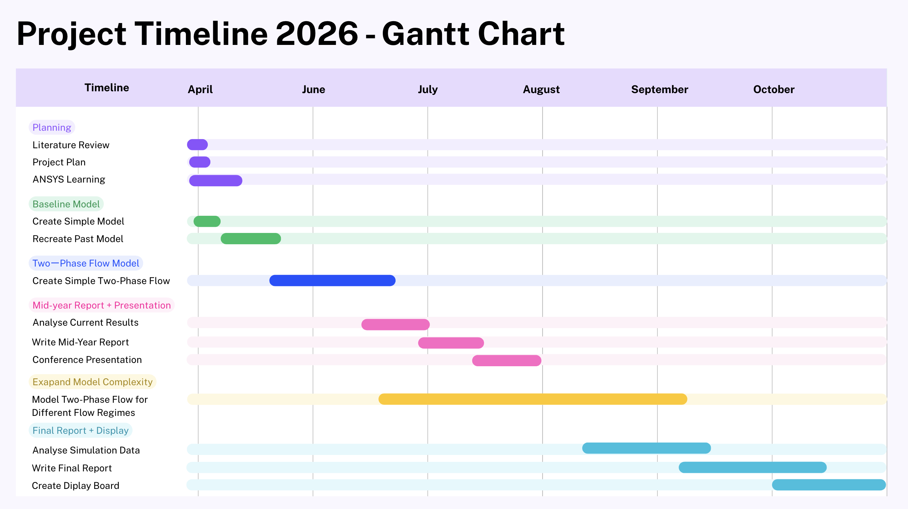

Introduction

Background and Context
Geothermal energy is an important part of New Zealand’s electricity generation because it provides reliable renewable baseload power. In liquid-dominated geothermal systems, production wells emit a two-phase mixture of steam and water, which must be separated before the steam enters the turbine. Effective separation is necessary to maintain steam quality and to reduce erosion, scaling, and performance loss in downstream equipment.

Among the separator designs used in industry, the Bottom Outlet Cyclone (BOC) separator has become a common choice because of its high separation efficiency, relatively low pressure loss, and practical design. In this system, steam is separated from the incoming steam-water mixture by centrifugal action and directed toward the steam outlet, while the liquid phase is removed separately. However, separator performance is strongly influenced by the condition of the incoming two-phase flow. In practice, the inlet fluid may appear in different flow regimes, such as slug, annular, and mist flow, depending on operating conditions including enthalpy and mass flow rate. These variations can alter the internal flow behaviour of the separator and affect its separation efficiency.

Problem Statement
Existing BOC separator design methods and CFD models provide useful insight, but they often rely on simplified inlet assumptions, particularly by treating the inlet flow as a uniform mist-like mixture. This does not fully represent the range of two-phase flow conditions encountered in geothermal operation, where inlet behaviour can vary significantly with changing well conditions. As a result, current predictions may not accurately capture separator behaviour across the full operating range, limiting their usefulness for design improvement and performance assessment.

Research Aim
This project aims to improve an existing CFD model of a vertical BOC separator by incorporating more realistic inlet flow conditions and evaluating how these conditions affect separator performance.

Research Objectives
The objectives of this project are:

- To review existing BOC separator design methods and CFD modelling approaches.
- To reproduce and assess an existing CFD model as a baseline for comparison.
- To implement representative two-phase inlet flow regimes within the CFD model.
- To investigate how inlet flow regime influences internal flow behaviour and predicted separation efficiency.
- To compare the refined model with available reference or field data where possible.

Project Scope
This project focuses on a vertical BOC separator and the effect of inlet flow conditions on its internal flow behaviour and separation performance. The study is limited to the separator vessel, its inlet region, and the representation of different two-phase inlet conditions within the CFD model. Downstream equipment and the wider steam gathering network are outside the scope of this work.

Literature Review

Current state of geothermal steam-water separation
Steam–water separation is a core performance requirement in geothermal power production because turbine efficiency, reliability, and maintenance cost depend on very high steam purity. Reported guidance commonly requires turbine inlet steam quality above 99.5%, ideally with less than 1% wetness, to limit droplet impingement and mineral deposition on blades, nozzles, casings, and diaphragms. Field troubleshooting work adds tighter chemical constraints, including TDS below 5 ppm and chloride, silica, and iron each below 1 ppm, showing that separator performance is not only a hydrodynamic issue but also a chemistry-control issue. This matters at plant scale: even a separator operating at 99.995% efficiency would still pass about 5 kg/h of liquid carryover at a steam flow of 100 t/h (Rivas-Cruz et al., 2015). Separator design therefore has to minimise both moisture and dissolved solids, not simply maximise nominal centrifugal separation (Umanzor & Zarrouk, 2022;Zarrouk & Purnanto, 2015).
Among geothermal separator types, vertical cyclone separators are generally preferred over horizontal gravity units because they are more compact, have lower pressure drop, and can achieve high efficiency without moving parts. Review data indicate that roughly 70% of surveyed plants used vertical separators and about 30% used horizontal designs, while both types can achieve efficiencies around 99.9% when properly designed (Zarrouk & Purnanto, 2015). Within the vertical class, the Bottom Outlet Cyclone (BOC) separator has become the dominant configuration. Its advantage is not only hydrodynamic; by removing steam near ground level, it simplifies steamline support relative to older top-outlet cyclone arrangements (Rizaldy et al., 2016; Santoso & Zarrouk, 2017; Zarrouk & Purnanto, 2015).
The BOC operates by introducing the two-phase mixture tangentially or through a spiral inlet to generate a strong vortex. Liquid is driven toward the wall and downward, while steam occupies the low-pressure core and moves upward. Reported performance for BOC units lies broadly in the 99.5%–99.99% range, with best operation typically occurring at inlet velocities of about 30–40 m/s; beyond roughly 42 m/s, outlet steam quality deteriorates rapidly. The main inlet configurations discussed in the literature are the Bangma circular tangential inlet, the Lazalde-Crabtree rectangular tangential inlet, and the spiral inlet, shown schematically in Figure 1. Spiral inlets are repeatedly favoured over the earlier tangential designs because they introduce the flow more smoothly, reduce abrupt wall impact, and create a more uniform high-velocity region near the outer wall.
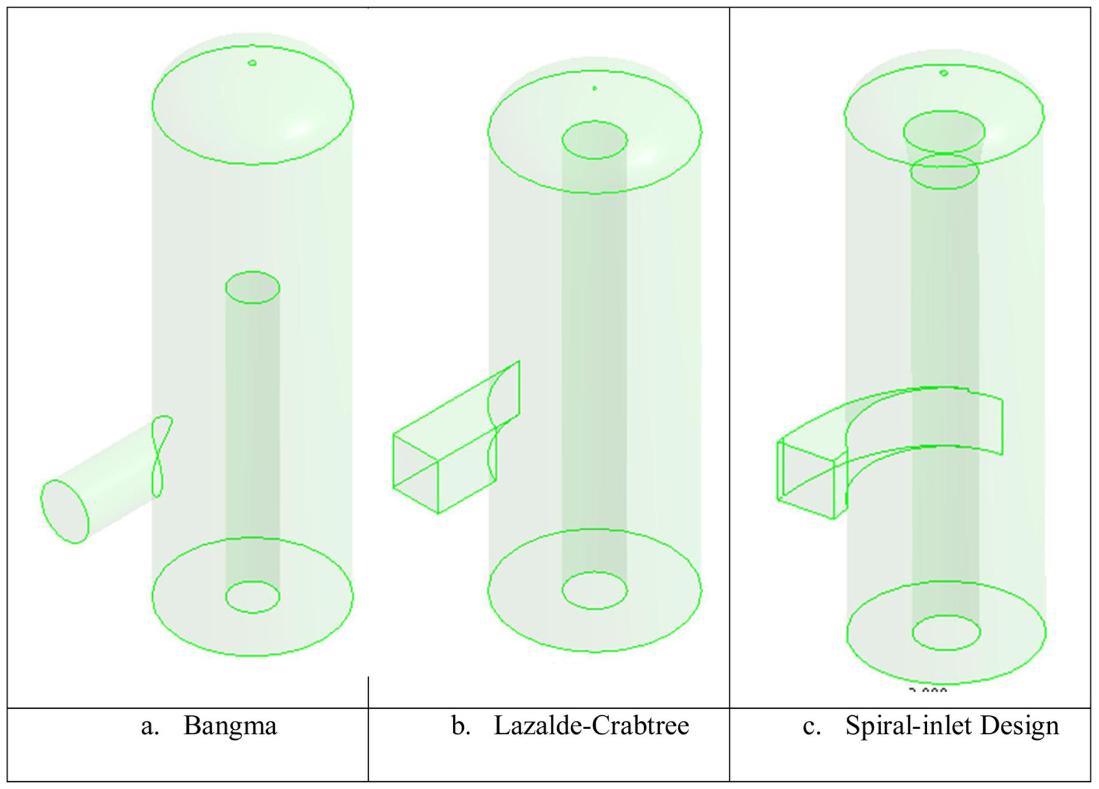
Figure 1: Separator geometry based on (a) Bangma (1961), (b) Lazalde-Crabtree (1984), and (c) spiral-inlet.

In effect, inlet design is not a minor geometric detail but a primary control on angular momentum, pressure loss, and liquid transport (Purnanto et al., 2013; Zarrouk & Purnanto, 2015).
However, as seen below in Figure 3, centrifugal separation alone does not determine performance.
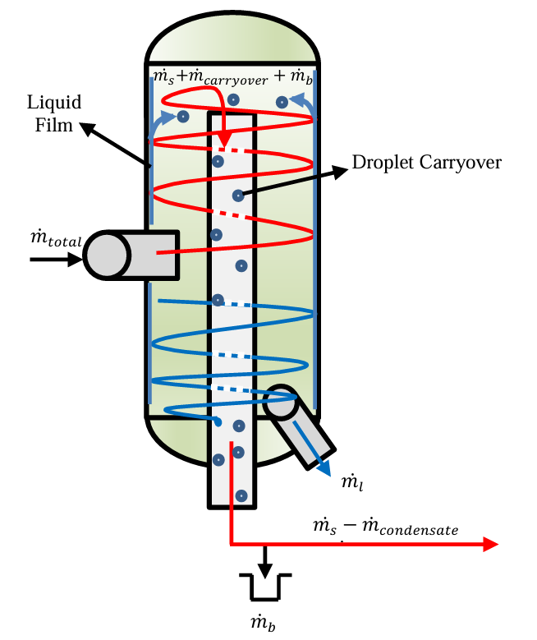
Figure 2: Internal mass flow

Once the bulk phases separate, a wall film forms and becomes a second source of carryover. Upward spiralling steam can strip droplets from this liquid film and re-entrain them into the vapour core, so actual performance depends on wall-film thickness, liquid loading, and steam–liquid relative velocity as much as on bulk vortex strength. For that reason, separator efficiency must be interpreted together with pressure drop: stronger swirl generally improves separation, but only at the cost of additional pressure loss. The literature therefore frames separator design as a balance between steam quality, re-entrainment control, and acceptable pressure drop rather than a single-efficiency problem. This also explains why inlet structure matters so strongly: the separator does not receive a featureless two-phase mixture, but a regime-conditioned inlet that already carries its own film, droplet, and momentum structure (Rizaldy et al., 2016; Zarrouk & Purnanto, 2015).

Two-Phase Inlet Flow Regimes and Their Relevance to Separator Performance
The fluid entering a geothermal separator is highly structured and varies with pressure, enthalpy, mass flow, pipe diameter, and upstream flashing. Representative field enthalpies are reported at about 1100–1325 kJ/kg, separator pressures at roughly 9.05–12.5 bar(a), and total two-phase mass flows up to 500 kg/s, while one commonly cited CFD baseline used 1600 kJ/kg (Chan & Zarrouk, 2023; Mubarok & Zarrouk, 2016; Purnanto et al., 2013; Umanzor et al. (2021)). Specific field examples underline this variation: the Berlin case was reported at 9.9 bar(a), 97.6 kg/s total flow, 21.3 kg/s steam flow, and 1201 kJ/kg, whereas the Ulubelu slugging case involved 9.27 bar(a), 1152 kJ/kg, 1313 t/h, and a 0.91 m pipeline. These values show that separator inlet conditions are not narrow or ideal; they span a wide operating envelope that a useful model must be able to represent (Chan & Zarrouk, 2023; Mubarok & Zarrouk, 2016; Purnanto et al., 2013; Umanzor et al., 2021).
Within this envelope, geothermal pipelines can exhibit stratified, wave, slug, annular, and mist flow.
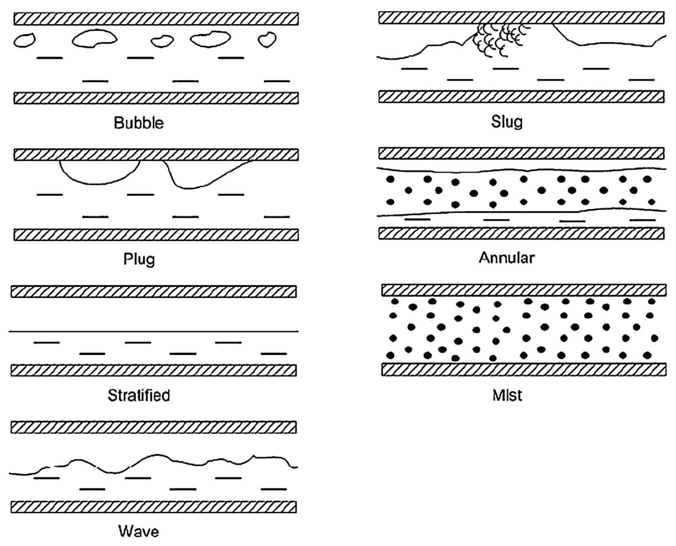
Figure 3: Two-phase flow patterns in horizontal flow (after Harrison, 1975; Allen, 1977).

For the present project, the important point is not to rehearse standard definitions, but to note that these regimes differ in liquid distribution, interfacial structure, entrainment, and momentum transfer before the flow ever reaches the separator. Recent work moves beyond simple two-phase descriptions and treats the inlet more realistically as a three-field system: a wall film, a vapour core, and entrained droplets (Chan & Zarrouk, 2023). That formulation is especially relevant because it aligns with the physical mechanism already identified inside the separator, namely wall-film stripping and droplet re-entrainment.
This upstream structure matters because separator performance is regime-sensitive. The literature notes that cyclone separators perform well only within a designed inlet regime, and that off-design behaviour can reduce separation efficiency and increase outlet wetness (Santoso & Zarrouk, 2017; Zarrouk & Purnanto, 2015). Some older observations even suggest that slug-flow inlets may, in some cases, separate better than annular inlets, while annular flow has been associated with separator failure. Yet slug flow is mechanically undesirable upstream because it can produce severe vibration, as reported at Ulubelu. The design problem is therefore not trivial: the regime that may locally assist separation is not necessarily the regime that is operationally acceptable for the steam-gathering system (Mubarok & Zarrouk, 2016; Santoso & Zarrouk, 2017; Zarrouk & Purnanto, 2015).
The literature also ties inlet behaviour to entrainment physics rather than to bulk dryness alone. In pipeline studies, droplet entrainment is linked to wall-film growth, roll-wave crest shearing, and critical gas velocity, which means the separator feed is shaped by upstream film dynamics before entering the cyclone. This is the central transition in the literature review: if inlet structure governs droplet loading, liquid film development, and incoming angular momentum, then separator CFD that assumes a uniform mist inlet is omitting a physically important part of the problem (Chan & Zarrouk, 2023).

Computational Representation of Two-Phase Flow and Existing Separator CFD
The computational literature shows that no single multiphase model is ideal for all inlet structures. Bulk geothermal two-phase flow has often been represented using mixture models, which are useful for pressure drop, mass flow, and thermodynamic predictions but do not explicitly resolve large deforming interfaces such as slugs or thick annular films. When the problem requires simultaneous treatment of a vapour core, entrained droplets, and a wall film, the literature moves toward Eulerian–Lagrangian or three-field approaches. These are more physically appropriate for annular-flow entrainment problems, but they are also numerically more delicate and are developed mainly for straight-pipe annular flow rather than for cyclone inlets (Mondal & Sharma, 2024; Skoog, 2020).
Computational treatment of geothermal two-phase flow depends on how explicitly the inlet structure must be represented. For bulk transport problems, mixture or Eulerian bulk models are useful because they can predict pressure drop, mass flow, and thermodynamic behaviour without resolving large deforming interfaces. Mubarok et al. (2020), for example, used an SST k$-ω$ mixture model with a coupled solver and showed that this approach can provide stable and credible bulk-flow predictions for geothermal applications. However, such models do not explicitly resolve slug structure, annular liquid films, or droplet stripping.
When the problem requires simultaneous treatment of a vapour core, entrained droplets, and wall film, the literature moves toward Eulerian–Lagrangian or three-field methods. Mondal and Sharma (2024) and Skoog (2020) both used this type of framework for annular-flow problems, showing that it is better suited to entrainment and film-transport physics, although it is also numerically more delicate. Existing separator CFD studies have successfully reproduced internal cyclone flow patterns and nominal separator trends, but they still rely mainly on idealised mist or mist-annular inlet assumptions rather than realistic upstream regime structure (Chan & Zarrouk, 2023; Mondal & Sharma, 2024; Mubarok et al., 2020; Purnanto et al., 2013; Skoog, 2020; Zarrouk & Purnanto, 2015). Taken together, the literature can model bulk geothermal flow, idealised annular entrainment, or simplified separator droplet tracking, but not yet the full transition from realistic large-diameter pipeline regimes into a geothermal cyclone separator.
Taken together, these approaches show that current computational practice can represent bulk geothermal flow and idealised annular entrainment, but not yet the full transition from realistic large-diameter pipeline regimes into a strongly swirling geothermal cyclone separator. That gap is reinforced by solver behaviour. Even straight-pipe annular simulations required tight controls such as DPM under-relaxation of 0.15 or reduced transverse injection velocities to maintain convergence, indicating that phase slip and entrainment are already numerically delicate before swirl, curvature, and centrifugal separation are introduced (Mondal & Sharma, 2024; Skoog, 2020).
Published separator CFD has nevertheless produced useful results under simplified conditions. The geothermal literature is concentrated around a small number of Fluent-based studies that used particle tracking to examine separator proportions, inlet geometry, and droplet removal. These simulations captured the expected internal cyclone structure, including high velocity near the outer wall and lower pressure at the core, and they reproduced the qualitative superiority of spiral over tangential inlets. Under idealised conditions, agreement with empirical Lazalde-Crabtree predictions was strong, with reported differences of about 0.02%–0.18% depending on the design. A separate summary reported 99.987% removal of injected droplets for a Lazalde-Crabtree separator (Chan & Zarrouk, 2023). These are important results because they show that CFD can reproduce nominal separator trends when the inlet is simplified.
The limitation is that the same studies idealised the inlet and much of the separator boundary treatment. The most detailed baseline case used 200 kg/s, 1600 kJ/kg, and 11.2 bar(a), assumed a constant water level above the brine outlet, did not model the brine outlet flow explicitly, and distributed inlet droplets uniformly across the inlet surface using Harwell-estimated droplet sizes (Purnanto et al., 2013). Some particles remained “incomplete” even after the maximum tracking steps were increased, and one workaround was simply to assume that these particles had separated. At the reporting level, turbulence-model detail, wall treatment, mesh structure, and grid-independence information were also incomplete. These choices made the CFD tractable, but they also limited reproducibility and narrowed the physical scope of the results.
The more important limitation is physical rather than purely numerical. Existing separator CFD largely omits the pre-separation that occurs in the upstream pipeline and therefore ignores the non-uniform liquid distribution, film development, and droplet loading that enter the separator in practice. This matters because off-design field behaviour can deviate markedly from nominal design expectations: Ulubelu separator efficiencies of 85.01%, 96.81%, and 99.82% were reported against a 99.95% design target, and anomalous CFD behaviour was also noted at 1600 kJ/kg and 27 m/s (Mubarok & Zarrouk, 2016; Purnanto et al., 2013). More broadly, steady-state equilibrium assumptions cannot capture transient wetness surges, slug impact, or separator breakdown events. Current CFD is therefore useful for nominal design comparison, but still weak as a predictive tool for realistic inlet-regime effects.

Optimisation Literature, Remaining Limitations, and the Research Gap
The optimisation literature has historically targeted steam purity and pressure drop by adjusting geometry, inlet velocity, and internal fittings rather than by modelling realistic inlet flow structure. Early design guidance established influential proportions relative to inlet diameter, including a body diameter of about 3D and water discharge 3D below the inlet. Under one cited pilot condition, a 30-inch separator with a 10-inch inlet and 3.5% water by volume achieved about 99.5% steam quality at 220 ft/s. Later work shifted attention toward inlet speed and liquid fraction, including a recommendation of 18 m/s for a 12-inch inlet under certain conditions. Other studies reported 99.97% separation for a modified Webre separator, equivalent to 0.03% brine carryover for a 100 MW plant, while Pointon et al. reported a baseline CFD prediction of 99.955%. These values show that optimisation has generated useful design rules, but they also show its main bias: optimisation has generally been performed around idealised or quasi-steady inlet assumptions (Pointon et al., 2009; Rivas-Cruz et al., 2015).
A second optimisation theme concerns internal appurtenances intended to suppress carryover and improve drainage. Reported modifications include plates below the ceiling plate, drainage paths returning collected liquid to the brine stream, inverted cones to alter inlet dynamics, and active drains between the dryer and turbine inlet steam. Such measures are important because they implicitly acknowledge that re-entrainment and solids transport remain problematic even when nominal steam quality is high. One reported example found that steam quality of about 99.99% coexisted with solids separation efficiency as low as 33%. This is a strong reminder that separator performance should not be reduced to a single dryness number (Rivas-Cruz et al., 2015).

Appropriate Middle Sections

Appropriate Middle Sections

Appropriate Middle Sections

Discussion

Conclusions

Future Work

Acknowledgements
Thank important people here. Be sure to thank your mum.

References
[Insert Automatically Generated Bibliography]
Chan, K. F., & Zarrouk, S. J. (2023). Modelling Particle Tracking of Moisture Droplets in Geothermal Steam Pipeline.
Mondal, A., & Sharma, S. L. (2024). Modeling and simulation of air-water upward annular flow characteristics in a vertical tube using CFD. Nuclear Engineering and Technology, 56(7), 2881–2892. https://doi.org/10.1016/j.net.2024.05.022
Mubarok, M. H., Cater, J. E., & Zarrouk, S. J. (2020). Comparative CFD modelling of pressure differential flow meters for measuring two-phase geothermal fluid flow. Geothermics, 86. https://doi.org/10.1016/j.geothermics.2020.101801
Mubarok, M. H., & Zarrouk, S. J. (2016). STEAM-FIELD DESIGN OVERVIEW OF THE ULUBELU GEOTHERMAL PROJECT, INDONESIA.
Rivas-Cruz, F., García-Gutiérrez, A., Martínez-Estrella, J. I., & Ortiz-Bolaños, Á. A. (2015). Design and Evaluation of Geothermal Steam Separators: A Review of the State of Art. In GRC Transactions (Vol. 39).
Santoso, Y. A., & Zarrouk, S. J. (2017). Geothermal Steam Water Separator Sizing for Optimizing Power Plant Cost.
Skoog, E. (n.d.). CFD Annular Flow Modelling Based on a Three-Field Approach.
Umanzor, C., & Zarrouk, S. J. (2022). The Steamfield Process Design and Optimisation Tool (SPDOT).
Umanzor, C., Zarrouk, S. J., & Rodríguez, A. (2021). Steam Purity Troubleshooting: The Berlin Geothermal Steam Field, El Salvador.
Zarrouk, S. J., & Purnanto, M. H. (2015). Geothermal steam-water separators: Design overview. In Geothermics (Vol. 53, pp. 236–254). Elsevier Ltd. https://doi.org/10.1016/j.geothermics.2014.05.009

Appendix A: The First Appendix
Appendix Text

Appendix B: Second Appendix
Some appendix text.

